I’m translating English to [ ]

(please write which language you’re translating!!)

Few words from Anne:

Thank you sooooo much for saying yes for the help!!!! I REALLY appreciate it!

The translations don’t need to be super strict and accurate,

(well if you can it def works better but don’t be stressed about it) all good as long as that makes sense to native speakers

AND if you don’t have the exact word or sentence/or hard to translate into one word/sentence, just leave it [blank]

Thanksss and ask me any questions if u guys havee!!

Let’s get this doneee >>>>>>>

NO NEED to be translated. Just for reference/context

Need to be translated! Actual sentences that being translate

**Screen #1 Language selection**

**Tone: Friendly :)**

*- Before we get started…*

*With which languages can you communicate?*

*What’s your language(s)?*

*- I can communicate with…..*

*(After selection)*

Sounds perfect!

OR

That’s awesome!

☺ ***Your translation here:***

**Screen #2 Pre-game**

**Tone: Friendly :)**

Hello and welcome to (game title)!

Let’s dive into the language ocean, shall we?

* I’d like to start with *word game.*
* I love challenges! Let’s go with *sentence game.*

☺ ***Your translation here:***

**Screen #2.5 During the game**

**Tone: Friendly :)**

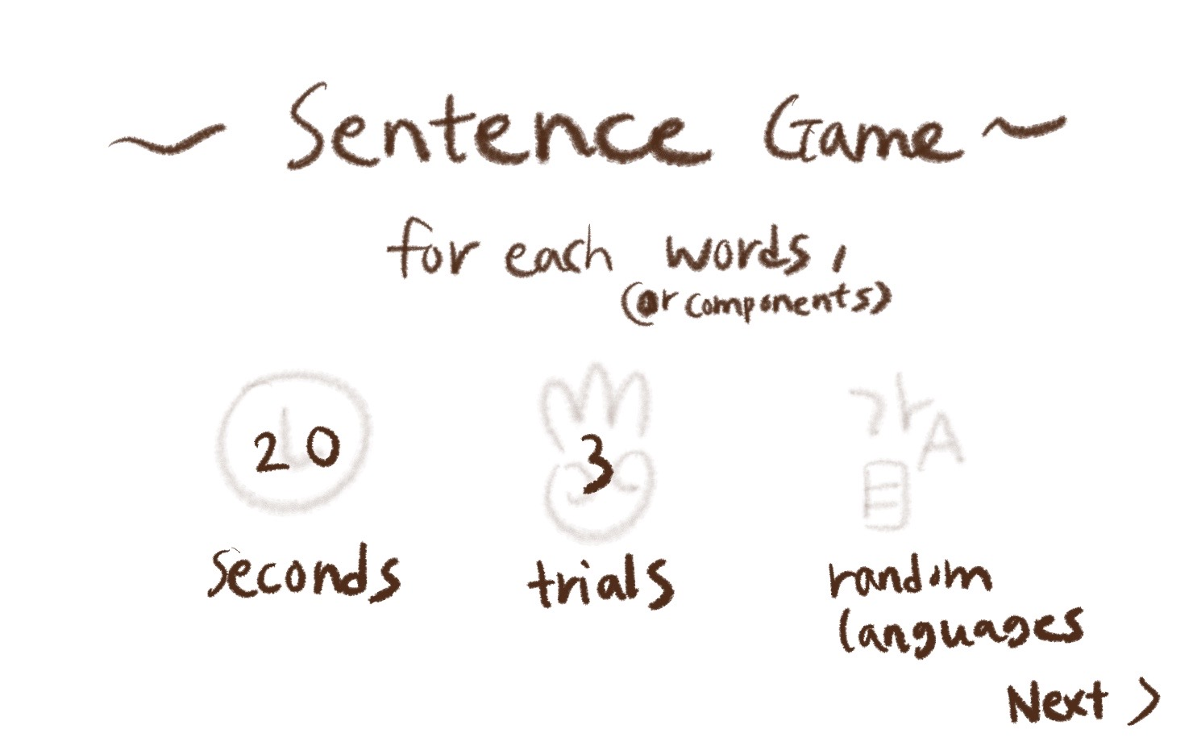

(The screen will be like this!!)

For each word, (OR components) ☺ ***Your translation here:***

Trials (OR CHANCES) ☺ ***Your translation here:***

Seconds (AS TIME) ☺ ***Your translation here:***

Random Languages ☺ ***Your translation here:***

___________________________________________

What do you think it means?

☺ ***Your translation here:***

Type… (AS A ‘TYPE HERE’)

☺ ***Your translation here:***

You got it right!

☺ ***Your translation here:***

For the first trial, you wrote:

For the second trial, you wrote:

For the third trial, you wrote:

☺ ***Your translation here:***

The answer was ___ .

☺ ***Your translation here:***

next >>

(THIS IS A BUTTON FOR THE NEXT GAME)

☺ ***Your translation here:***

You were so close!

(IF THE PLAYER DIDN’T GET THE ANSWER)

☺ ***Your translation here:***

HOORAY!

You finished the game.

((OR)) That’s the end of the game.

(IT’S OKAY IF ‘HOORAY’ COULD NOT BE THE SAME IN YOUR LANGUAGE.

EXCITEMENTS LIKE ‘YEY!’ WOULD BE AWESOME.)

☺ ***Your translation here:***

Back to game >>

(RETURNING BUTTON)

☺ ***Your translation here:***

**Screen #3 Word game**

**Tone: dictionary form**



Apple

☺ ***Your translation here:***



wave

☺ ***Your translation here:***



Shopping bag

☺ ***Your translation here:***



introduce

☺ ***Your translation here:***

coffee

☺ ***Your translation here:***

**

frozen

☺ ***Your translation here:***

**

photography

☺ ***Your translation here:***



Reject

☺ ***Your translation here:***



Love

☺ ***Your translation here:***



Water

☺ ***Your translation here:***

**Screen #4 Sentence game**

**Tone: dictionary form**

Instruction:

So what I’m gonna do here is making a sentence game with each different language for each component.

For instance:

I / 사과 / 好きです

apple(in KR) like(in JP)

= I like apple.

So please write it into two forms if it’s possible:

Top one: as a sentence

Bottom one: dictionary form for each components

If your language has a different grammar, you don’t need to follow the separation and the order I gave, just classify them as they are :)

Also, those sentences contain some humors lol

I love to procrastinate.

I / love / to / procrastinate

☺ ***Your translation here(AS A SENTENCE):***

☺ ***Your translation here(SEPARATED COMPONENTS):***

I want a green apple.

I / want / a green apple

☺ ***Your translation here(AS A SENTENCE):***

☺ ***Your translation here(SEPARATED COMPONENTS):***

Don’t make me run.

Don’t / make / me / run

☺ ***Your translation here(AS A SENTENCE):***

☺ ***Your translation here(SEPARATED COMPONENTS):***

I would like to have one cute cat, please.

I / would / like to / have / one cute cat /, please

☺ ***Your translation here(AS A SENTENCE):***

☺ ***Your translation here(SEPARATED COMPONENTS):***

I have zero in my bank account.

I / have / zero(nothing) / in / my / bank account

☺ ***Your translation here(AS A SENTENCE):***

☺ ***Your translation here(SEPARATED COMPONENTS):***

At least I have my sandwich with me.

At least / I / have / my / sandwich / with me

☺ ***Your translation here(AS A SENTENCE):***

☺ ***Your translation here(SEPARATED COMPONENTS):***

I love lying in my bed all day.

I / love / lying in / my bed / all day.

☺ ***Your translation here(AS A SENTENCE):***

☺ ***Your translation here(SEPARATED COMPONENTS):***

I woke up at 5:00pm.

I / woke up / at / 5:00pm.

☺ ***Your translation here(AS A SENTENCE):***

☺ ***Your translation here(SEPARATED COMPONENTS):***

***THATS ALL FOR TRANSLATION!! YEY***

***And JUST FOR FUN, if you’d like to share:***

Words/expressions/sentences that doesn’t exist in English?:

(For instance, ‘귀찮아(gwichana)’ in Korean means ‘that’s too much work so I would rather not do it’ but the dictionary says ‘its annoying,’ which is not a good refleciton 😂)